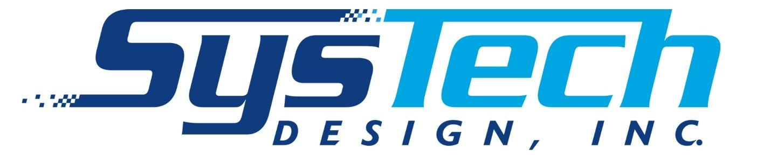

Code of Conduct

Preamble

SysTech Design, Inc. was borne on the engineering principles of industrial ventilation and associated disciplines that impact successful system implementation. As an integrator of industrial ventilation systems, SysTech undertakes projects for industrial health and safety to ensure air quality in our client's industrial environments, along with associated fire and explosion protection and noise control.
As such, our business decorum and the various manufacturers, consultants, and contractors we bring into a project are expected to always maintain an ethical and positive business presence.

Content

1. Purpose and Scope
2. Human Rights and Working Conditions
2.1. Child Labor
2.2. Non-Discrimination, non-harassment and Fair Treatment
2.3. Working Hours, Leave, and Compensation
3. Health and Safety
4. Environmental Standards
5. Business Ethics
6. Supply Chain
7. Compliance and Reporting Mechanisms

1. Purpose and Scope

The following code of conduct outlines the ethical and legal guidelines for all SysTech Design Inc. employees, suppliers, and business associates. SysTech Design Inc. strictly adheres to the principles and responsibilities outlined in this doctrine to ensure the moral and lawful integrity of business conducted within our organization and our network of partners. The areas encompassed in this code include:

  - Human Rights and Working Conditions
  - Health and Safety
  - Environmental Standards
  - Business Ethics
  - Supply Chain
  - Compliance and Reporting Mechanisms

2. Human Rights and Working Conditions

SysTech Design Inc. upholds and values the human rights of all individuals. We are committed to the ethical and lawful treatment of employees and other stakeholders affected by our business practices. We hold our employees, business partners, and suppliers accountable to the same standard of conduct. Our company extends this commitment to create a work environment that complies with the law and nurtures professional growth among our employees. These principles are fundamental to the integrity and safety of our operations.

2.1 Child Labor

SysTech Design Inc. stands firmly against the involvement of child labor in our business practices, and we fiercely oppose any kind of child exploitation. Our company strictly adheres to the legal employment statutes, ensuring every employee has completed their education requirements and is of legal working age. We are committed to safeguarding the well-being of young workers and we prevent their engagement in work that could be potentially harmful to their development. Systech Design Inc. promotes preventing and reporting human rights violations at all points along our supply chain.

2.2 Non-Discrimination, non-harassment, and fair treatment

SysTech Design Inc. guarantees that the employment and advancement opportunities within our company are determined solely by an individual’s knowledge, qualifications, and capability to fulfill their responsibilities. This procedure aligns with our intolerance for discrimination based on personal or cultural identities and extends to our selection of suppliers. SysTech Design Inc. does not tolerate any form of harassment within our company, whether it be verbal, psychological, physical, or sexual in nature. We are firm in our resolve to maintain a safe workplace that respects the dignity of all employees.

2.3 Working hours, leave, and compensation
Our company honors and abides by all applicable laws, contracts, and bargaining agreements that govern fair compensation and benefits as well as working, resting, and overtime hours. Our compliance also extends to the legal provisions of annual, sick, parental, and other applicable leave regulations.

3. Health and safety

At SysTech Design Inc., we prioritize the health and safety of our employees throughout our various operations. Our company follows the criteria defined by OSHA* to ensure our workplaces uphold the highest occupational health and safety standards. Employees are thoroughly trained in accordance with these standards to facilitate awareness of safe practices and potential hazards.

4. Environmental Standards

SysTech Design Inc. works with clients to create environmentally friendly designs that uphold legal standards. We recognize the responsibility of our company to preserve and protect the environment within our technical operations as well as our products. We strive to design and distribute our industrial ventilation systems in a way that minimizes emissions and optimizes energy efficiency.

5. Business Ethics

Our company is dedicated to conducting transparent and ethical business practices that uphold the dignity and safety of our clients, employees, suppliers, business partners, and community. The values of privacy, authenticity, and financial responsibility are central to our business’s ethical code of conduct.

We are unwavering in our commitment to preserving the privacy of our clients and employees, ensuring that sensitive information is protected and used strictly for agreed-upon business purposes. As part of our company’s financial responsibility, Systech Design Inc. maintains accurate and complete records of all financial transactions. These records are integral to our internal management and customer support. We also verify the authenticity of our products to prevent the circulation and distribution of counterfeit parts.

6. Supply Chain

At SysTech Design Inc., we believe that the ethical standards we employ are essential not only within our company but also within our greater supply chain. We hold our suppliers to the same moral standards that we maintain within our own internal operations. These expectations include compliance with local and federal law, fair wages and benefits for employees, prohibition of child labor, and respect for human rights.

7. Compliance and Reporting Mechanisms

Compliance with this code of conduct is enforced for all employees and suppliers of SysTech Design Inc. Deviation from these guidelines will be met with immediate corrective action to guarantee the preserved integrity of our company. Clients, employees, and business partners are urged to report violations of our policies. All reports remain confidential to protect your safety and privacy. We employ an anti-retaliation policy, protecting employees from retaliation when reporting non-compliance.

* With the Occupational Safety and Health Act of 1970, the United States Congress created the Occupational Safety and Health Administration (OSHA) to ensure safe and healthful working conditions for workers by setting and enforcing standards and by providing training, outreach, education, and assistance. The OSH Act covers most private-sector employers and their workers and some public-sector employers and workers in the 50 states and certain territories and jurisdictions under federal authority.

